PRACTICAL OSSP EXPERIMENTS – 2
Roll num: 2520030187 Harshit Sajjanapu

Program-1:
(Cmd executor code program)

Code:
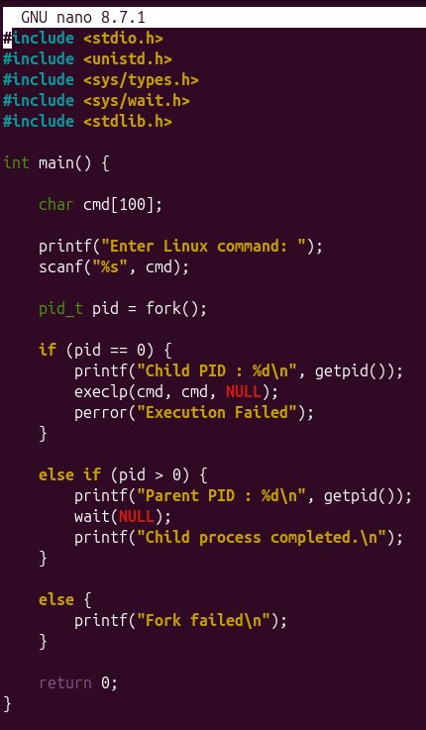
Output:
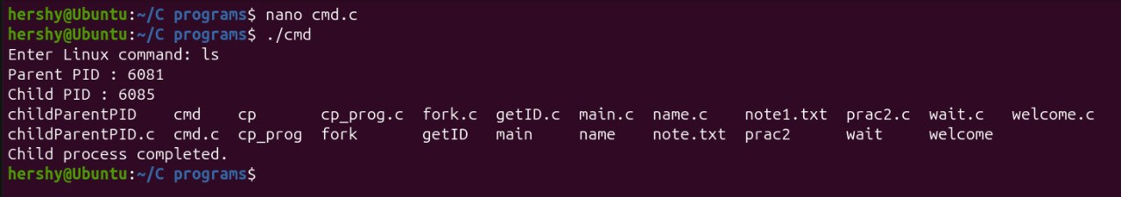

Experiment – 2:
Copy content file from “note.txt” to note1.txt”
Code:
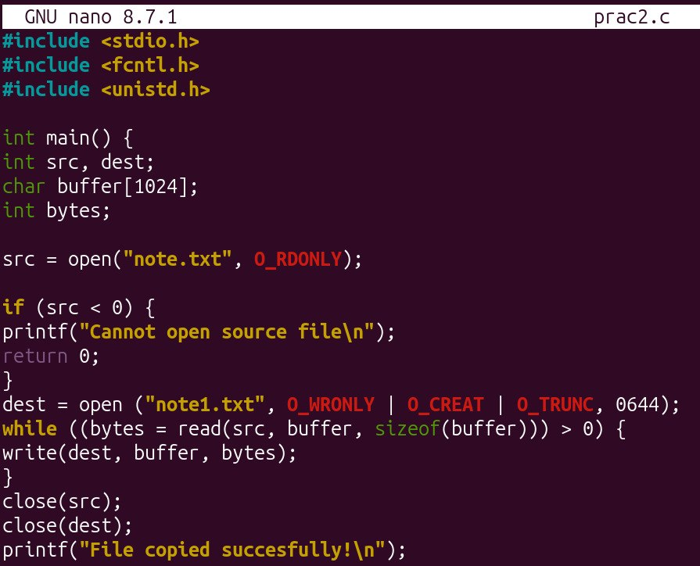

Output:
